

BATTERY POWERED INVERTER WELDER BA150BW

USER MANUAL

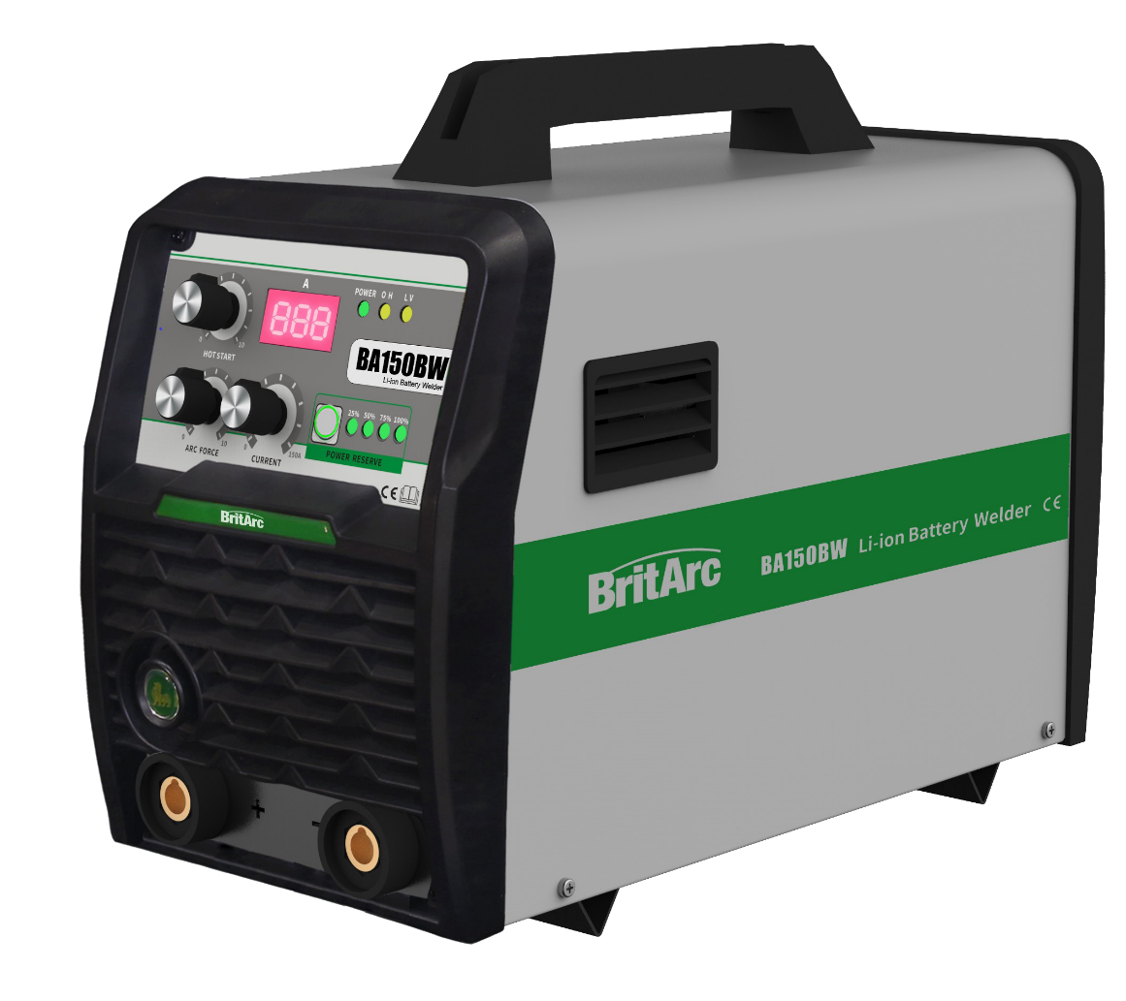

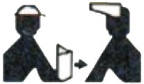Before use, please read this User Manual carefully.

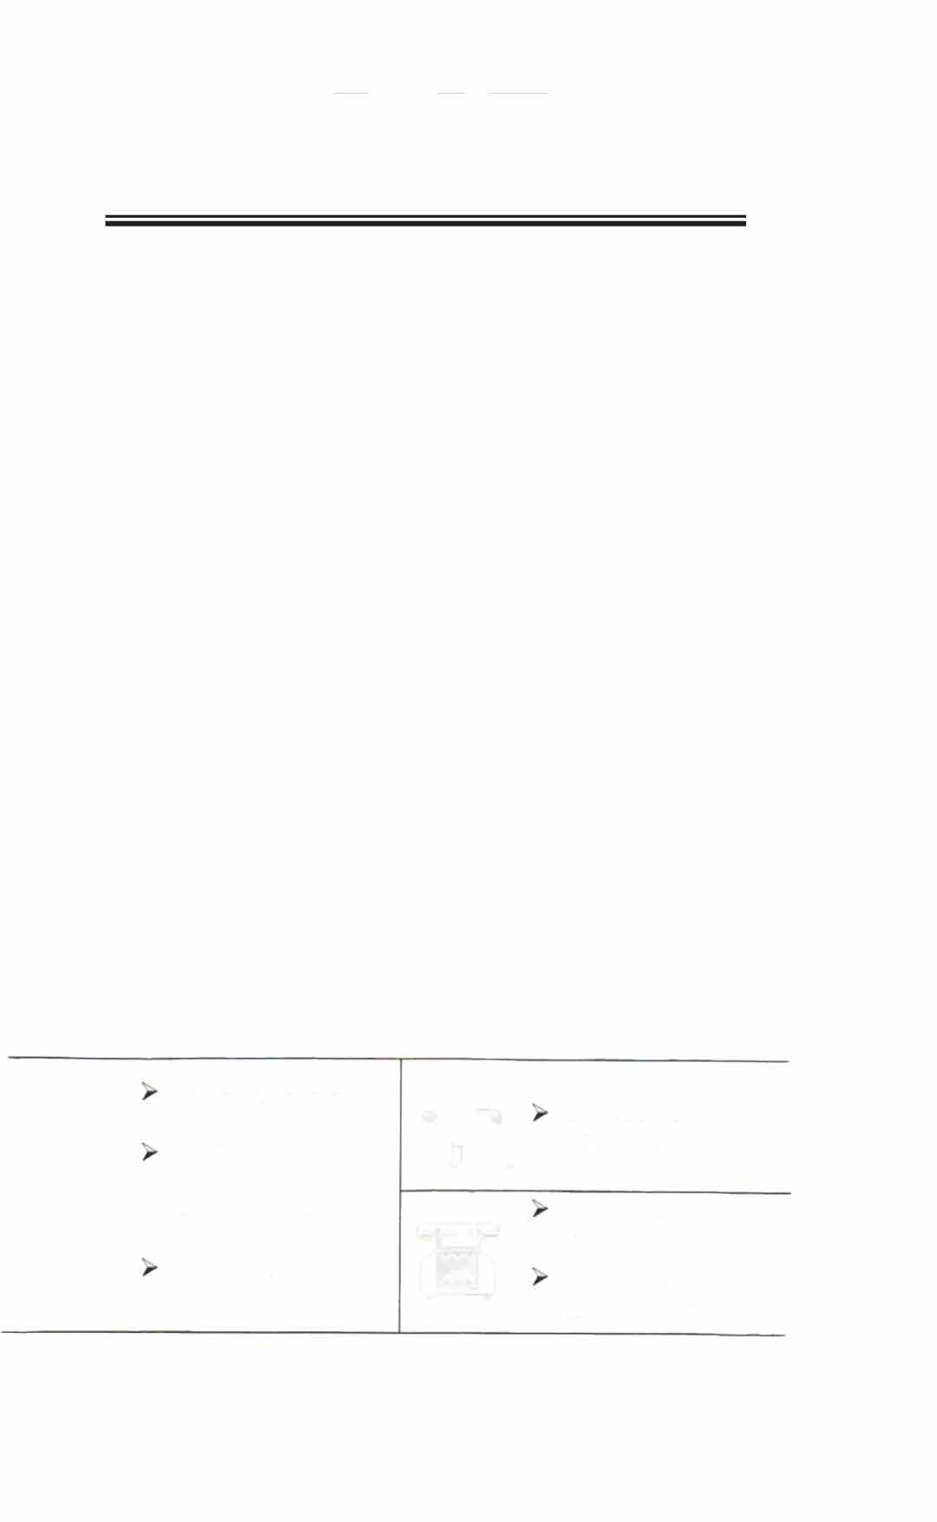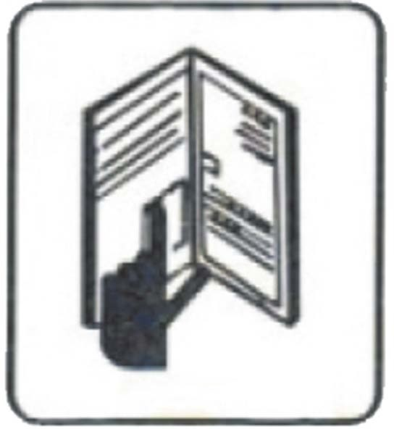

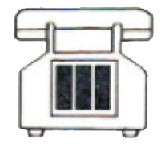This User Manual is used for operation and maintenance of this battery welder only.

In case of any questions, please contact your dealer.

Please hand this User Manual to the welder operator.

In case of any questions, contact the branches or dealers.

Or directly contact the User Service Department of the Head Office.











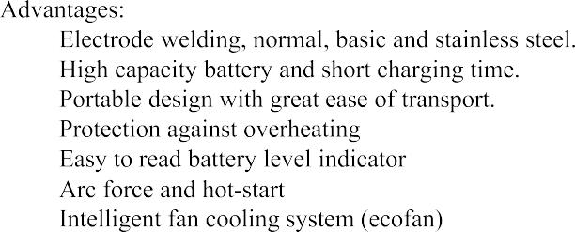

|  |  |
| --- | --- |
| **Battery Powered Inverter Welder BA150BW** | |
|  |  |
|  |  |
|  |  |
|  |  |
|  |  |
|  |  |
|  |  |
|  |  |
|  |  |
|  |  |
|  |  |
|  |  |



**OVERALL DIMENSION OF BA150BW BATTERY POWERED WELDER**





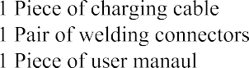





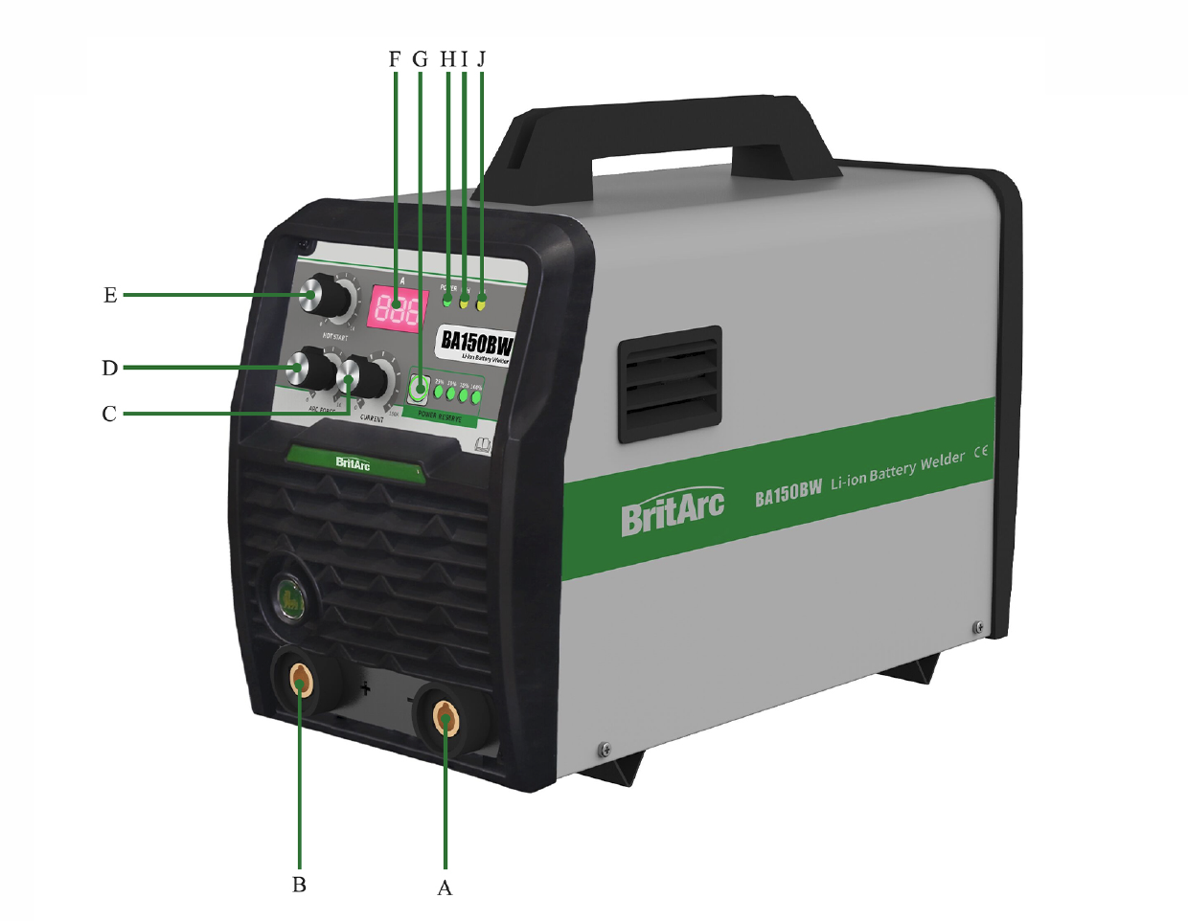

|  |  |  |
| --- | --- | --- |
|  |  |  |
|  |  |  |
|  |  |  |
|  |  |  |
|  |  |  |
|  |  |  |
|  |  |  |
|  |  |  |
|  |  |  |
|  |  |  |
|  |  |  |

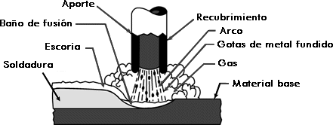









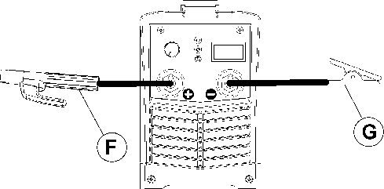





|  |  |  |  |  |  |
| --- | --- | --- | --- | --- | --- |
|  | | | | | |
|  |  |  |  |  |  |
|  |  |  |  |  |  |
|  |  |  |  |  |  |
|  |  |  |
|  |  |  |
|  |  |  |  |  |  |
|  |  |  |
|  |  |  |  |  |  |
|  |  |  |
|  |  |  |













|  |  |  |
| --- | --- | --- |
|  |  |  |
|  |  |  |
|  | |  |
|  |  |  |
|  |  |  |
|  |  |  |
|  | |
|  |  |  |
|  | |
|  |  |  |
|  |  |
|  |  |
|  |  |  |
|  |
|  |  |  |
|  |  |  |
|  |  |
|  |  |
|  |  |





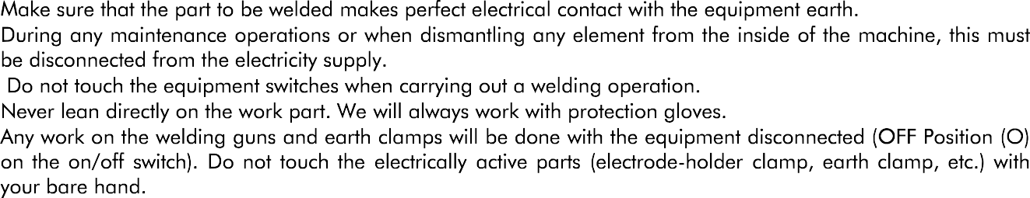

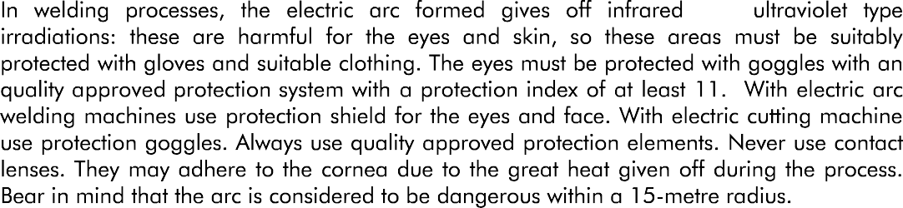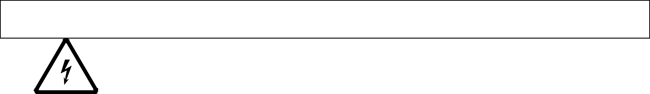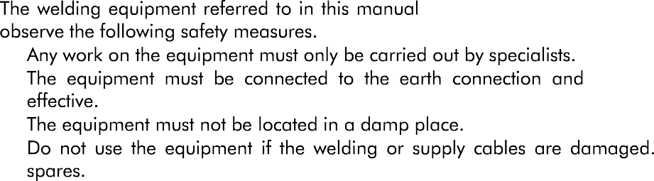



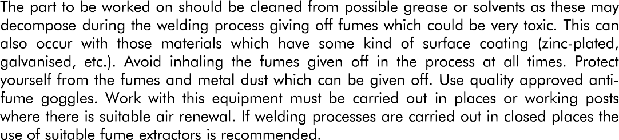

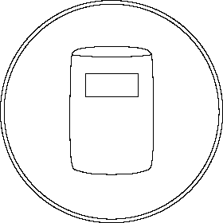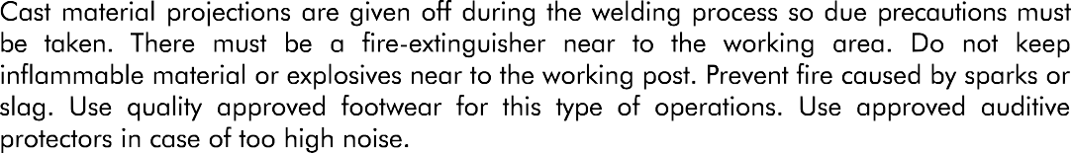

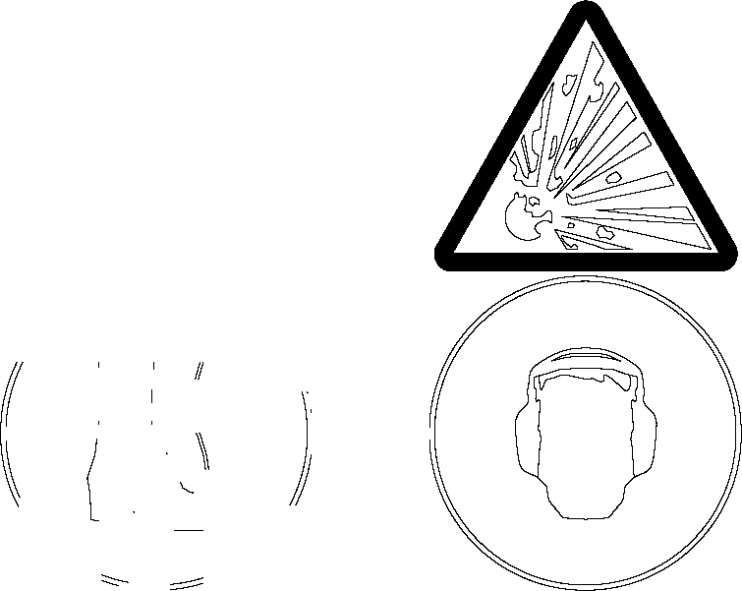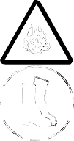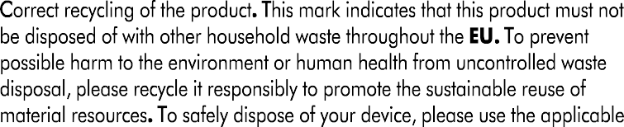

10